Game Design Document

Fill up the following document

1. Write the title of your project.

Which Element Defines You : Earth , Water , Air , o Fire?

1. What is the goal of the game?

Is to known what element of the earth are you .

1. Write a brief story of your game.

This is a story of four powers of the Earth (Water ,Air , Fire or Earth) . They all are very powerful and are inside each and every person and even inside animals and this is the best way or I can say this is the best game to know which person is of which element of the earth . Earth indicates as deep as land or soil

Water indicates as cold or as transparent thing

Air indicates as light as wind blowing a leaf

Fire indicates as angry as red colour .

So , my story ends over here . Hope you enjoyed the story . . . . . .

1. Which are the playing characters of this game?

* Playing characters are the ones who respond to the user based on the input from the user.
* Cars, monkeys, dinos, wizards, etc., are the playing characters in the game.

|  |  |  |
| --- | --- | --- |
| Number | Character Name | What can this character do? |
| 1 | Earth | Take you into the deep research of something . |
| 2 | Water | Make you feel cold or can show what you are from inside . |
| 3 | Air | Make you feel light and will help you to be strong and not to blow with it like a leaf . |
| 4 | Fire | Test your angryness and make you control your feelings . |
| 5 |  |  |
| 6 |  |  |
| 7 |  |  |
| 8 |  |  |

1. Which are the Non-Playing Characters of this game?

* Non-Playing characters are the ones that don't have an action or behavior when the user interacts with the game.
* Hurdles, stones, bananas, coins, etc., are non-playing characters in the game.

|  |  |  |
| --- | --- | --- |
| Number | Character Name | What can this character do? |
| 1 |  |  |
| 2 |  |  |
| 3 |  |  |
| 4 |  |  |
| 5 |  |  |
| 6 |  |  |
| 7 |  |  |
| 8 |  |  |

Draw your imagination of this game. What does this game look like?

* Draw the game either on your computer or on paper.
* Add images of the game scenes to show each of the playing and non-playing characters at least once.

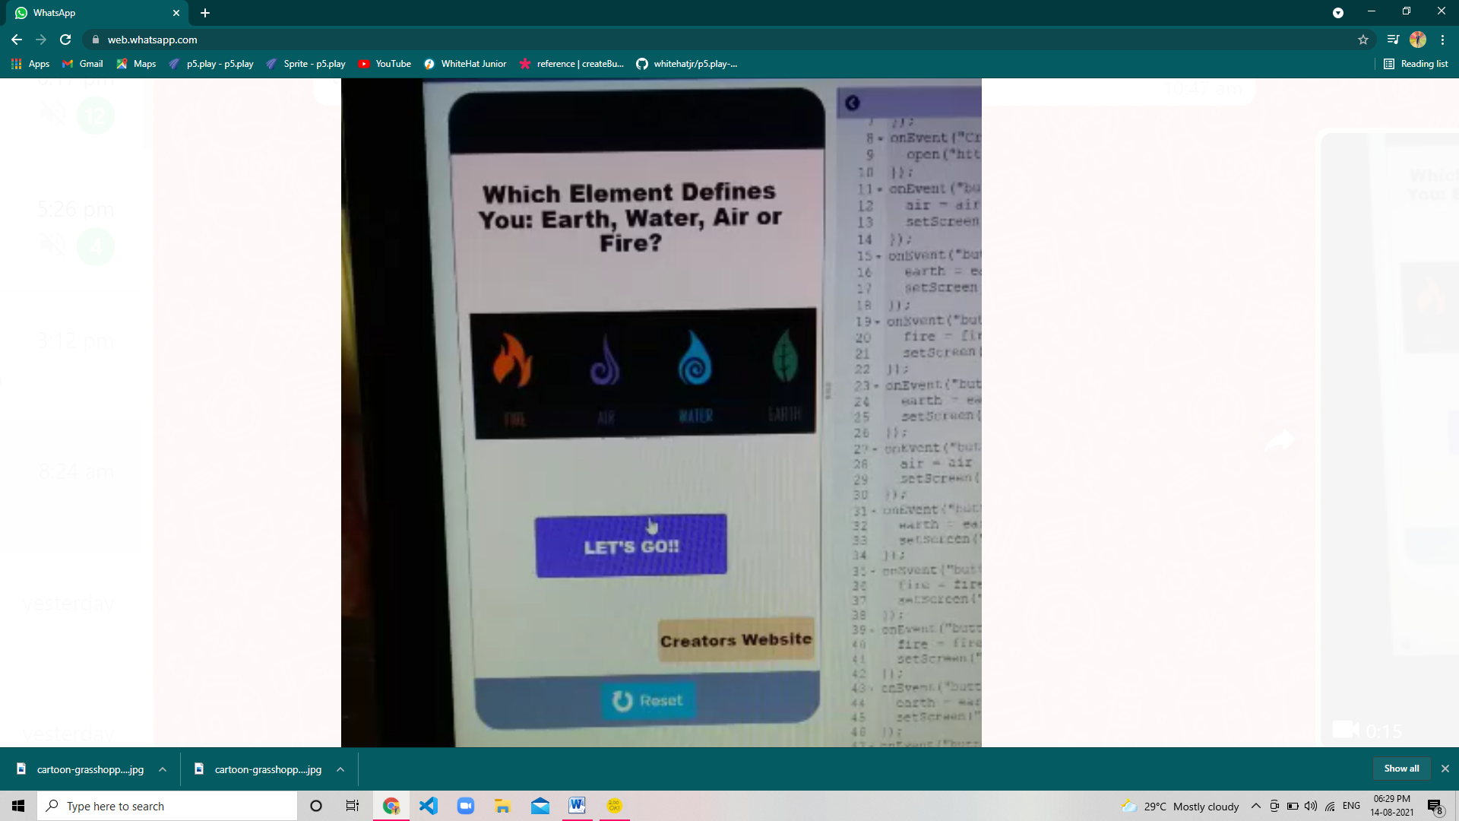 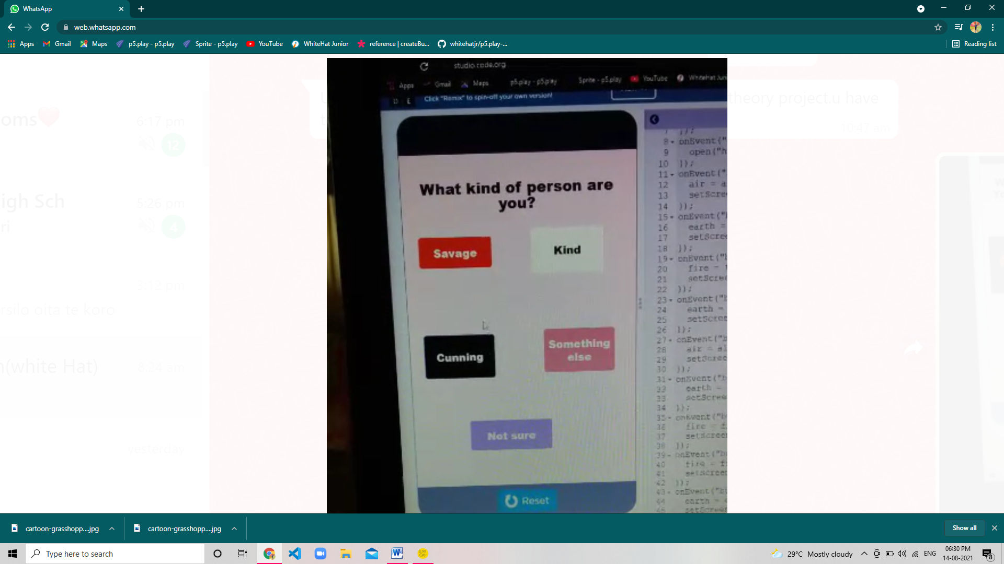 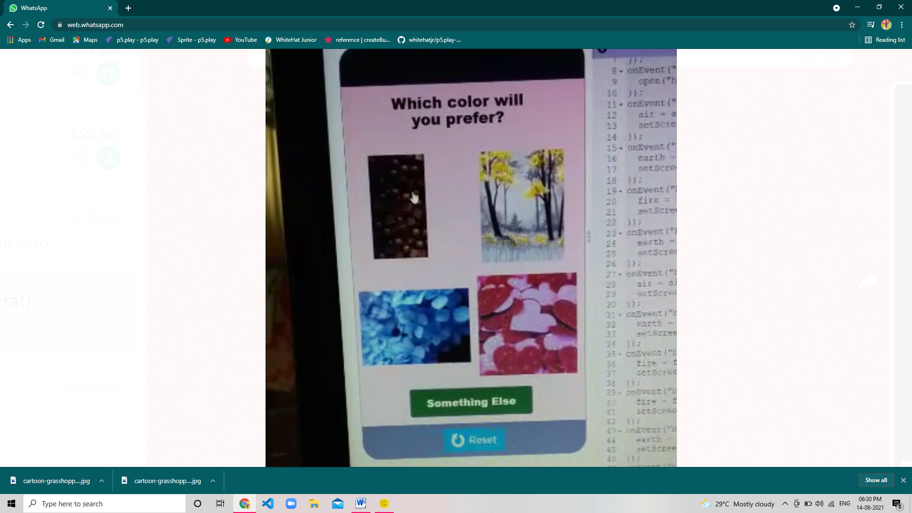 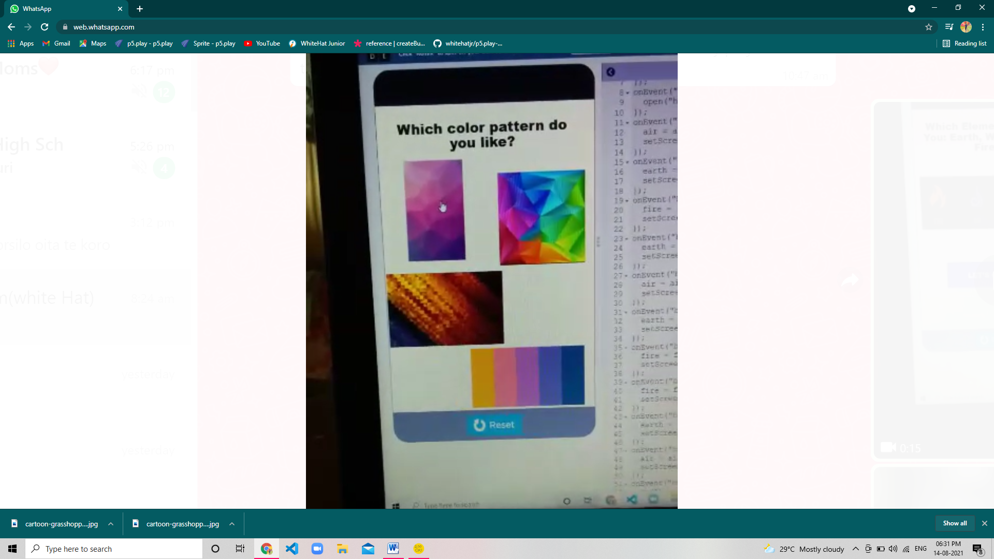 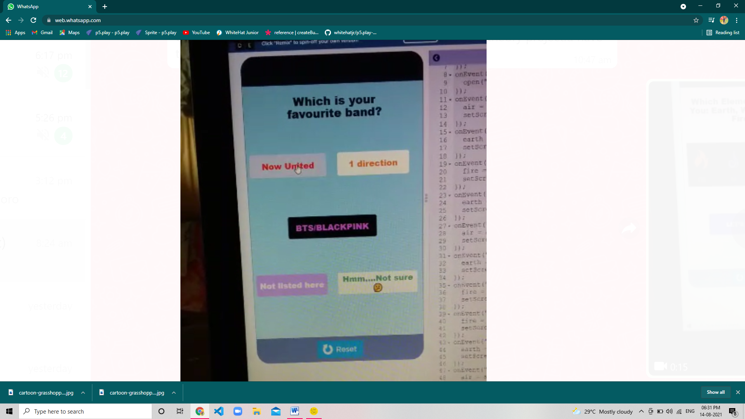 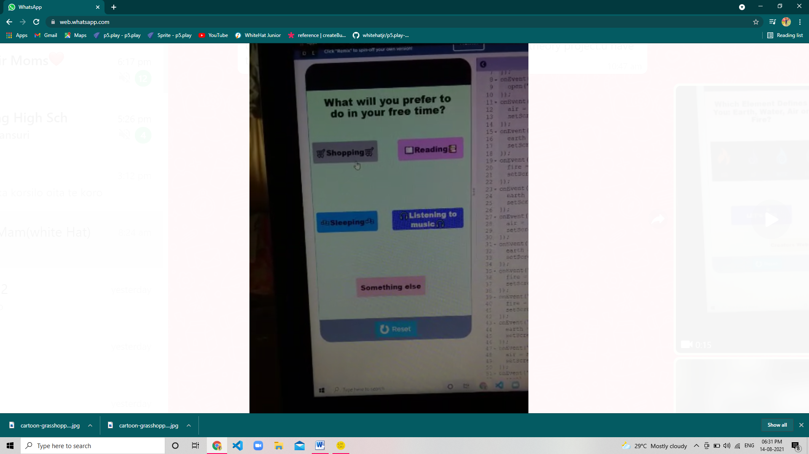 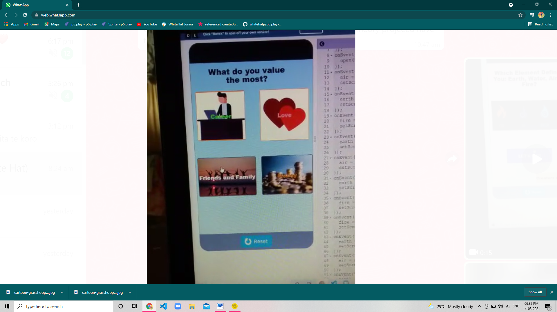 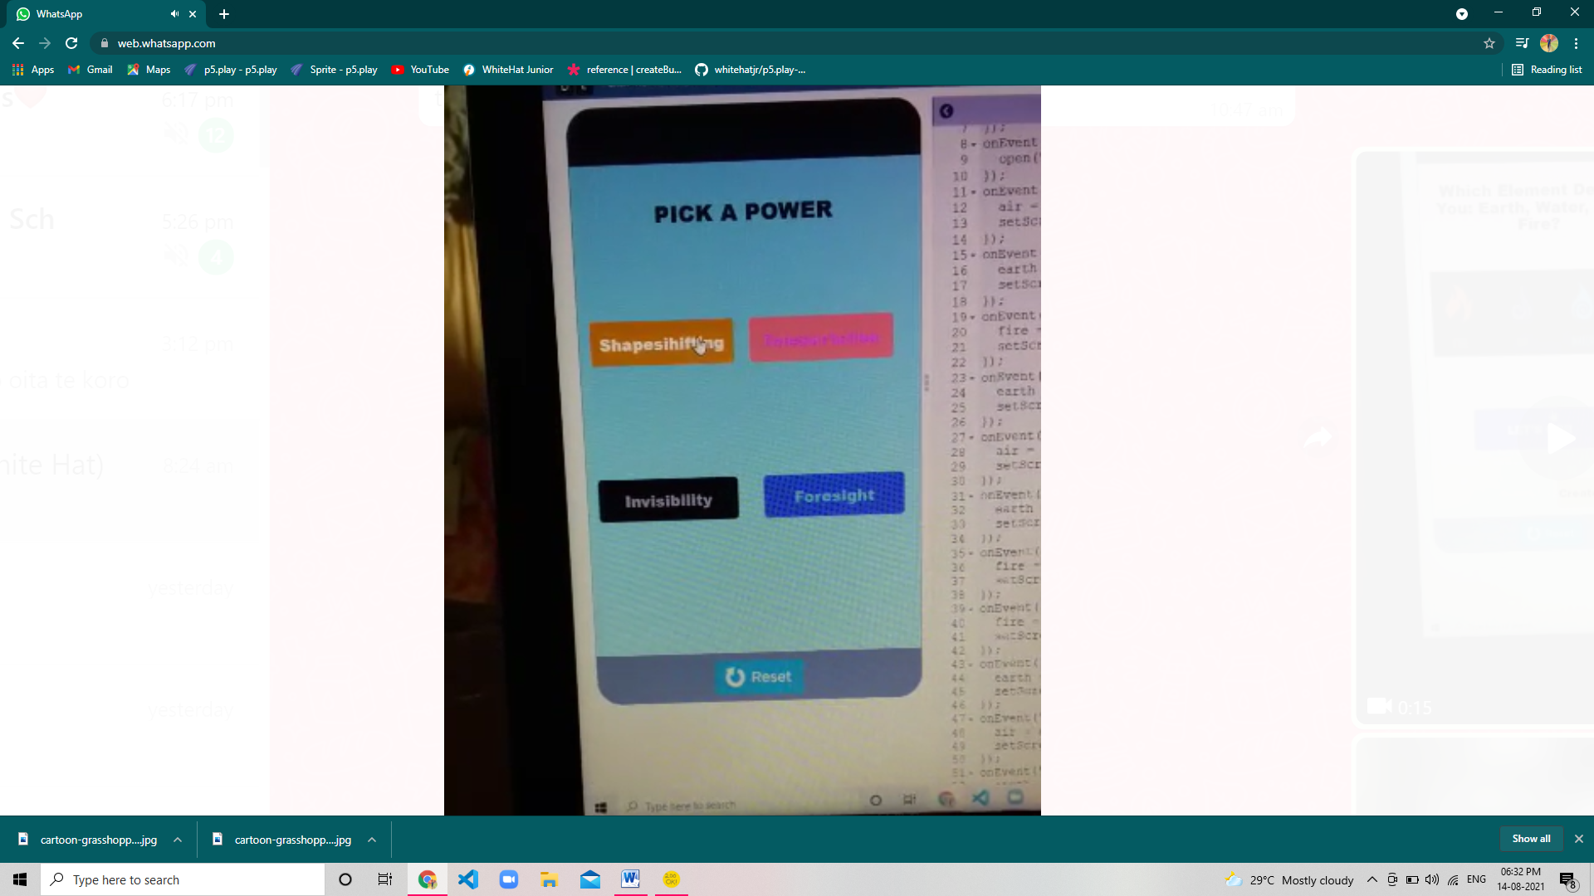 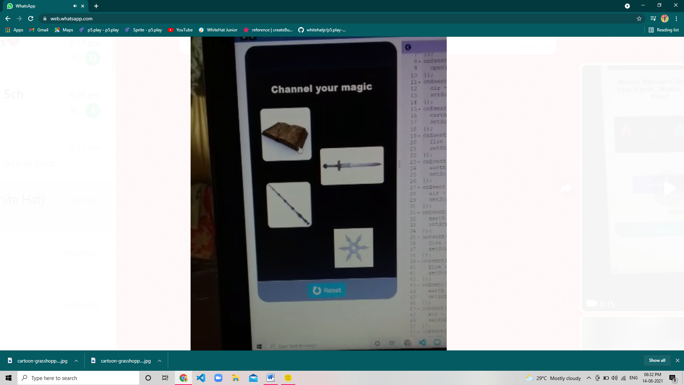 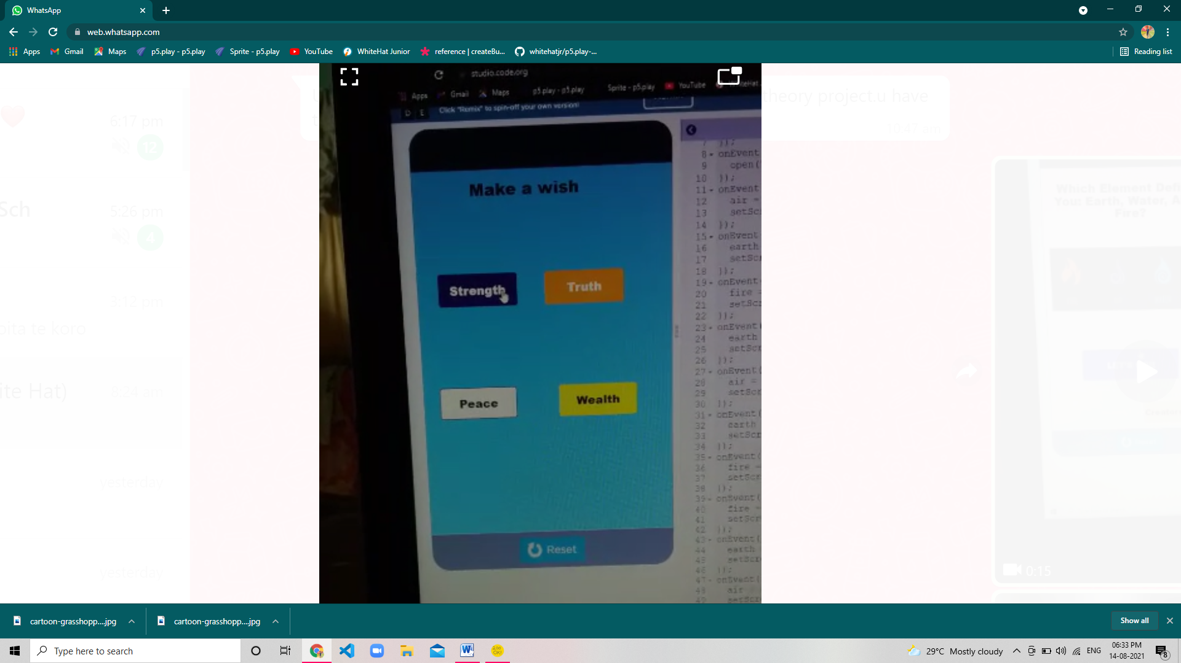 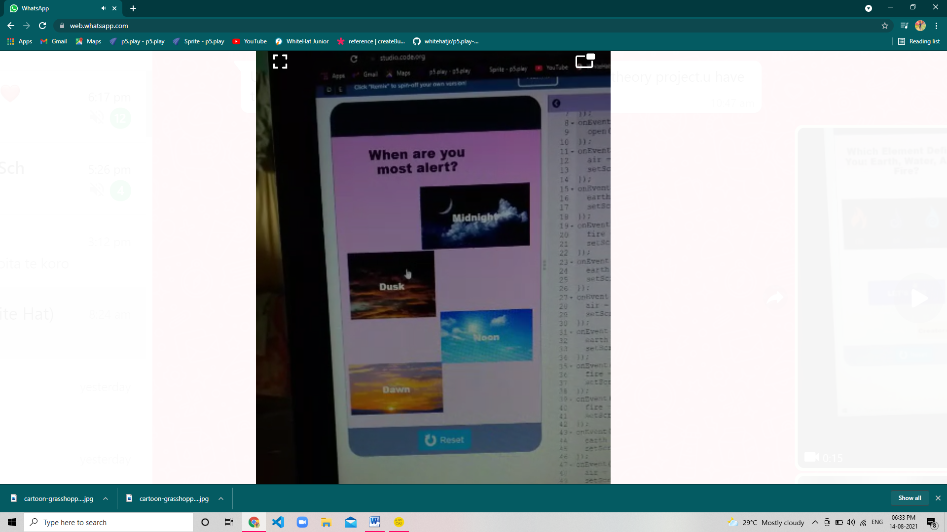 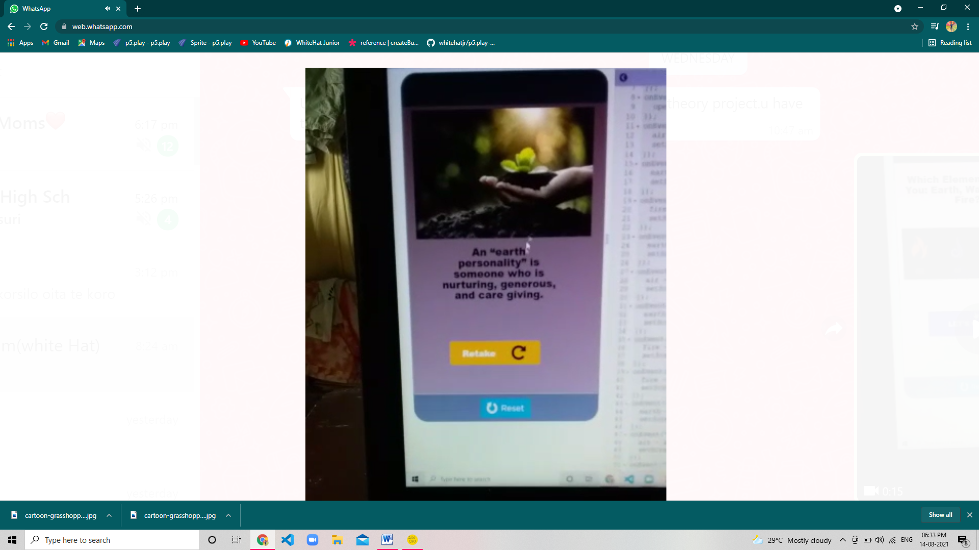

How do you plan to make your game engaging?